
BCSE302L- Database Systems
Register Number | 24BCE1731 | Subject Code | BCSE302L
Name of the Student | Abhinav Bhuniya | Subject Name | Database Systems
Programme | BTech CSE | DA-2
Date | 08/04/2026

School: SCOPE
Project Title: Inventory & Supplier Management System
Course Code: BCSE302L
Course Title: Database Management Systems
Class Number: CH2025260501233
Semester: Winter 2025-26
Slot: A1+TA1
Team members: Abhinav Bhuniya, 24BCE1731
Aveek Sanyal, 24BCE1081
Gaurav Satyedev, 24BCE1828
Course Faculty: Dr. L.M. Jenila Livingston

1. INTRODUCTION
This project is an Inventory & Supplier Management System developed to manage products, suppliers, purchase orders, stock, and payments.
The system demonstrates:
- CRUD operations
- Relational database design
- Use of foreign keys
- JOIN queries for data retrieval
The database schema was designed using ER modeling and then converted into relational tables. This assignment focuses on normalization and backend schema design.

2. LIST OF RELATIONS (FROM ER MAPPING)
- PRODUCT(product_id, product_name, category, unit_price)
- SUPPLIER(supplier_id, supplier_name, phone, email)
- PURCHASE_ORDER(order_id, product_id, supplier_id, quantity, order_date)
- STOCK(stock_id, product_id, available_quantity, last_updated)
- PAYMENT(payment_id, order_id, amount, payment_date, payment_mode)

3. NORMALIZATION PROCESS

3.1 PRODUCT TABLE

Original Table:
PRODUCT(product_id, product_name, category, unit_price)

Functional Dependency:
product_id → product_name, category, unit_price

Candidate Key:
product_id

1NF:
- All attributes are atomic
- No repeating groups
✔ Satisfies 1NF

2NF:
- No composite key
- No partial dependency
✔ Satisfies 2NF

3NF:
- No transitive dependency
✔ Satisfies 3NF

BCNF:
- Determinant is a super key
✔ Satisfies BCNF

Justification:
All attributes depend fully on the primary key. No redundancy or anomalies exist.

3.2 SUPPLIER TABLE

Original Table:
SUPPLIER(supplier_id, supplier_name, phone, email)

Functional Dependency:
supplier_id → supplier_name, phone, email

Candidate Key:
supplier_id

Normalization:
✔ Already in 1NF, 2NF, 3NF, and BCNF

Justification:
All attributes depend on a single primary key with no transitive or partial dependencies.

3.3 PURCHASE_ORDER TABLE

Original Table:
PURCHASE_ORDER(order_id, product_id, supplier_id, quantity, order_date)

Functional Dependency:
order_id → product_id, supplier_id, quantity, order_date

Candidate Key:
order_id

Normalization:
✔ 1NF: Atomic attributes
✔ 2NF: No composite key
✔ 3NF: No transitive dependency
✔ BCNF: Determinant is a super key

Justification:
Each order is uniquely identified by order_id and contains no redundant dependencies.

3.4 STOCK TABLE

Original Table:
STOCK(stock_id, product_id, available_quantity, last_updated)

Functional Dependency:
stock_id → product_id, available_quantity, last_updated

Candidate Key:
stock_id

Normalization:
✔ Already in BCNF

Justification:
All attributes depend directly on the primary key without redundancy.

3.5 PAYMENT TABLE

Original Table:
PAYMENT(payment_id, order_id, amount, payment_date, payment_mode)

Functional Dependency:
payment_id → order_id, amount, payment_date, payment_mode

Candidate Key:
payment_id

Normalization:
✔ Already in BCNF

Justification:
No partial or transitive dependencies exist.

4. FINAL RESULT OF NORMALIZATION
All tables are already in Boyce-Codd Normal Form (BCNF).
No further decomposition was required.

5. FINAL DATABASE SCHEMA (BCNF)
PRODUCT(product_id PK, product_name, category, unit_price)
SUPPLIER(supplier_id PK, supplier_name, phone, email)
PURCHASE_ORDER(order_id PK, product_id FK, supplier_id FK, quantity, order_date)
STOCK(stock_id PK, product_id FK, available_quantity, last_updated)
PAYMENT(payment_id PK, order_id FK, amount, payment_date, payment_mode)

6. CONSTRAINTS

Primary Keys:
- product_id
- supplier_id
- order_id
- stock_id
- payment_id

Foreign Keys:
- product_id → PRODUCT(product_id)
- supplier_id → SUPPLIER(supplier_id)
- order_id → PURCHASE_ORDER(order_id)

7. RELATIONSHIPS
- One Product → Many Purchase Orders
- One Supplier → Many Purchase Orders
- One Product → One Stock Record
- One Order → One Payment
8. BACKEND IMPLEMENTATION (SQL)
CREATE TABLE product (
product_id SERIAL PRIMARY KEY,
product_name VARCHAR(100),
category VARCHAR(50),
unit_price DECIMAL(10,2)
);

CREATE TABLE supplier (
supplier_id SERIAL PRIMARY KEY,
supplier_name VARCHAR(100),
phone VARCHAR(15),
email VARCHAR(100)
);

CREATE TABLE purchase_order (
order_id SERIAL PRIMARY KEY,
product_id INT,
supplier_id INT,
quantity INT,
order_date DATE,
FOREIGN KEY (product_id) REFERENCES product(product_id),
FOREIGN KEY (supplier_id) REFERENCES supplier(supplier_id)
);

CREATE TABLE stock (
stock_id SERIAL PRIMARY KEY,
product_id INT,
available_quantity INT,
last_updated TIMESTAMP,
FOREIGN KEY (product_id) REFERENCES product(product_id)
);
CREATE TABLE payment (
payment_id SERIAL PRIMARY KEY,
order_id INT,
amount DECIMAL(10,2),
payment_date DATE,
payment_mode VARCHAR(20),
FOREIGN KEY (order_id) REFERENCES purchase_order(order_id)
);

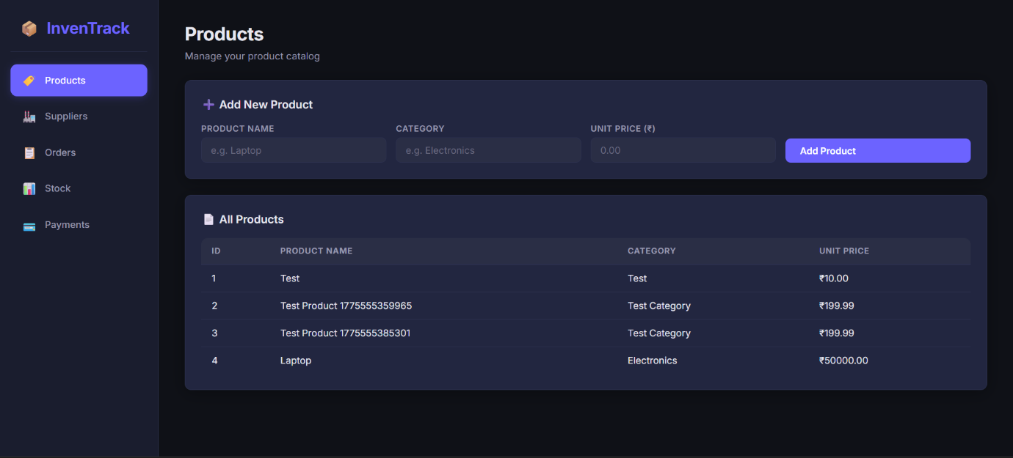
9. UI Screenshots
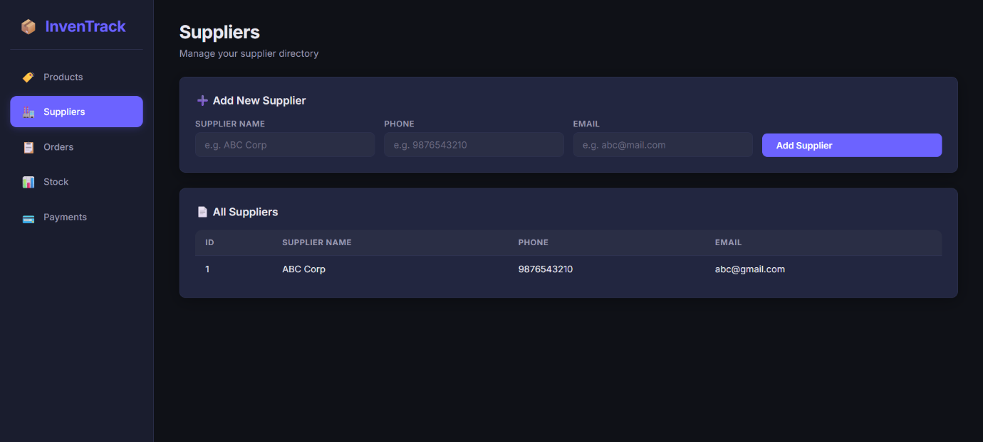

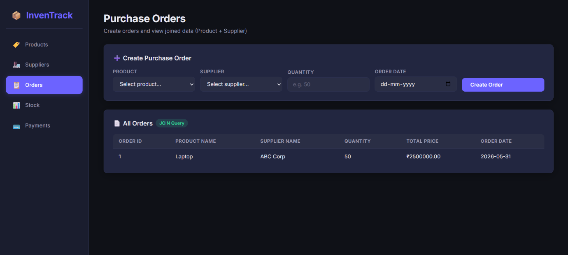

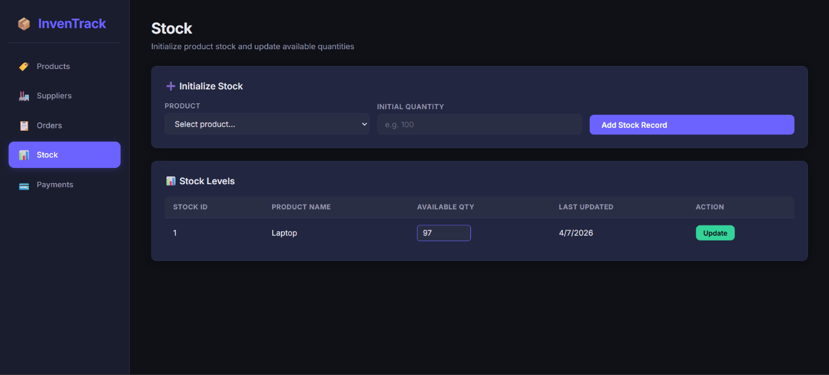

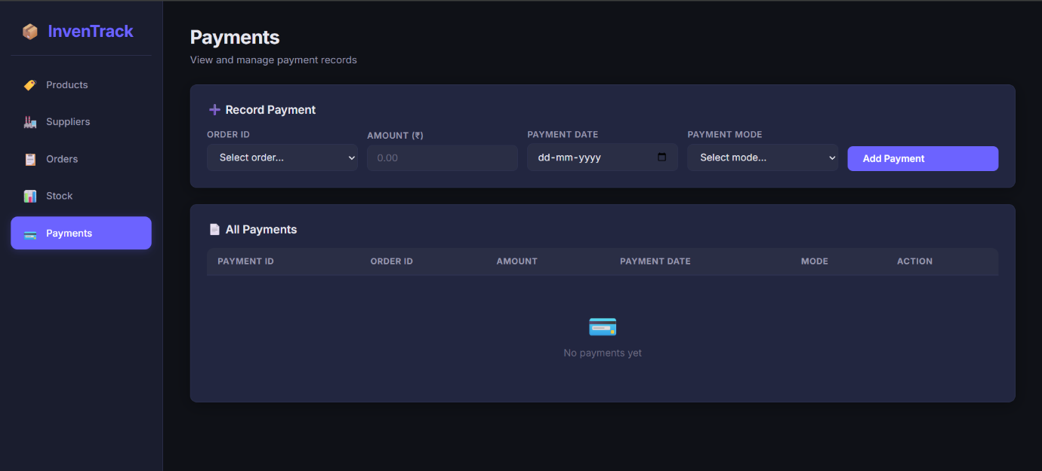

10. CONCLUSION
The database was successfully normalized up to BCNF, ensuring:
- Elimination of redundancy
- Prevention of update, insertion, and deletion anomalies
- Improved data consistency and integrity
The backend schema is clean, efficient, and ready for implementation, as demonstrated through the working system

